[](https://ok.ru/dk?cmd=PopLayerPhoto%26st.layer.cmd=PopLayerPhotoOuter%26st.layer.type=GROUP%26st.layer.revNav=off%26st.layer.limitedUi=false%26st.layer.closeLayers=off%26st.layer.sphotoIds=884887593780%3B884887594036%3B884887594548%3B884887595060%3B884887595572%3B884887595828%26st.layer.showNav=on%26st.layer.photoAlbumId=57249062780980%26st.layer.epm=off%26st.layer.photoId=884887593780%26st.layer.opl=off%26st.layer.navStartPhotoId=884887593780%26st.layer.sbd=off%26st.cmd=userStatuses%26st._aid=GroupTopicLayer_openPhotoLayer) [](https://ok.ru/dk?cmd=PopLayerPhoto%26st.layer.cmd=PopLayerPhotoOuter%26st.layer.type=GROUP%26st.layer.revNav=off%26st.layer.limitedUi=false%26st.layer.closeLayers=off%26st.layer.sphotoIds=884887593780;884887594036;884887594548;884887595060;884887595572;884887595828%26st.layer.showNav=on%26st.layer.photoAlbumId=57249062780980%26st.layer.epm=off%26st.layer.photoId=884887594036%26st.layer.opl=off%26st.layer.navStartPhotoId=884887594036%26st.layer.sbd=off%26st.cmd=userStatuses%26st._aid=GroupTopicLayer_openPhotoLayer)

[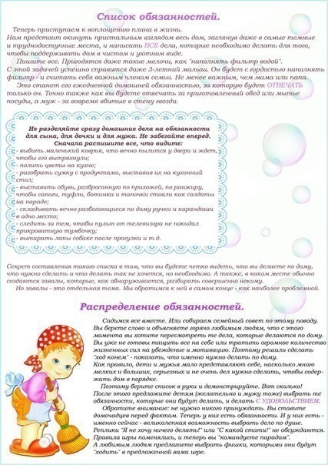](https://ok.ru/dk?cmd=PopLayerPhoto%26st.layer.cmd=PopLayerPhotoOuter%26st.layer.type=GROUP%26st.layer.revNav=off%26st.layer.limitedUi=false%26st.layer.closeLayers=off%26st.layer.sphotoIds=884887593780;884887594036;884887594548;884887595060;884887595572;884887595828%26st.layer.showNav=on%26st.layer.photoAlbumId=57249062780980%26st.layer.epm=off%26st.layer.photoId=884887594548%26st.layer.opl=off%26st.layer.navStartPhotoId=884887594548%26st.layer.sbd=off%26st.cmd=userStatuses%26st._aid=GroupTopicLayer_openPhotoLayer) [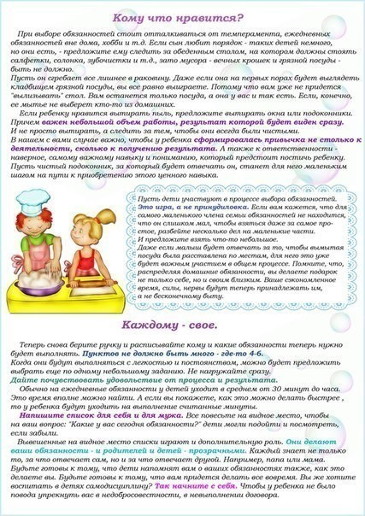](https://ok.ru/dk?cmd=PopLayerPhoto%26st.layer.cmd=PopLayerPhotoOuter%26st.layer.type=GROUP%26st.layer.revNav=off%26st.layer.limitedUi=false%26st.layer.closeLayers=off%26st.layer.sphotoIds=884887593780;884887594036;884887594548;884887595060;884887595572;884887595828%26st.layer.showNav=on%26st.layer.photoAlbumId=57249062780980%26st.layer.epm=off%26st.layer.photoId=884887595060%26st.layer.opl=off%26st.layer.navStartPhotoId=884887595060%26st.layer.sbd=off%26st.cmd=userStatuses%26st._aid=GroupTopicLayer_openPhotoLayer)

[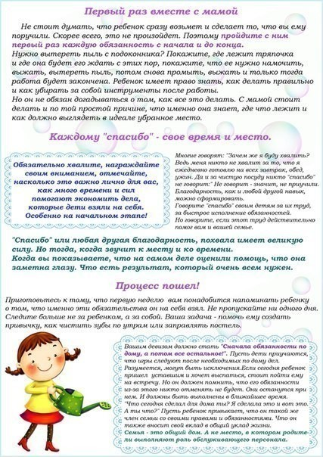](https://ok.ru/dk?cmd=PopLayerPhoto%26st.layer.cmd=PopLayerPhotoOuter%26st.layer.type=GROUP%26st.layer.revNav=off%26st.layer.limitedUi=false%26st.layer.closeLayers=off%26st.layer.sphotoIds=884887593780;884887594036;884887594548;884887595060;884887595572;884887595828%26st.layer.showNav=on%26st.layer.photoAlbumId=57249062780980%26st.layer.epm=off%26st.layer.photoId=884887595572%26st.layer.opl=off%26st.layer.navStartPhotoId=884887595572%26st.layer.sbd=off%26st.cmd=userStatuses%26st._aid=GroupTopicLayer_openPhotoLayer) [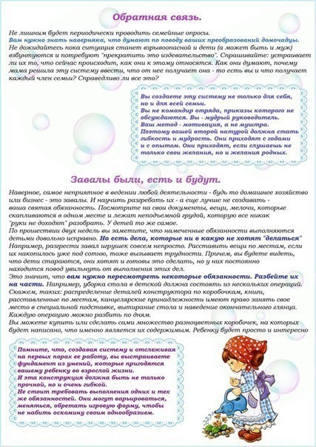](https://ok.ru/dk?cmd=PopLayerPhoto%26st.layer.cmd=PopLayerPhotoOuter%26st.layer.type=GROUP%26st.layer.revNav=off%26st.layer.limitedUi=false%26st.layer.closeLayers=off%26st.layer.sphotoIds=884887593780;884887594036;884887594548;884887595060;884887595572;884887595828%26st.layer.showNav=on%26st.layer.photoAlbumId=57249062780980%26st.layer.epm=off%26st.layer.photoId=884887595828%26st.layer.opl=off%26st.layer.navStartPhotoId=884887595828%26st.layer.sbd=off%26st.cmd=userStatuses%26st._aid=GroupTopicLayer_openPhotoLayer)